- Write a program to count all the prime and composite numbers entered by the user.
Sample Input:
Enter the numbers
4
54
29
71
7
59
98
23
Sample Output:
Composite number:3
Prime number:5
Test cases:
- 33, 41, 52, 61,73,90
- TEN, FIFTY, SIXTY-ONE, SEVENTY-SEVEN, NINE
- 45, 87, 09, 5.0 ,2.3, 0.4
- -54, -76, -97, -23, -33, -98
- 45, 73, 00, 50, 67, 44
OUTPUT:

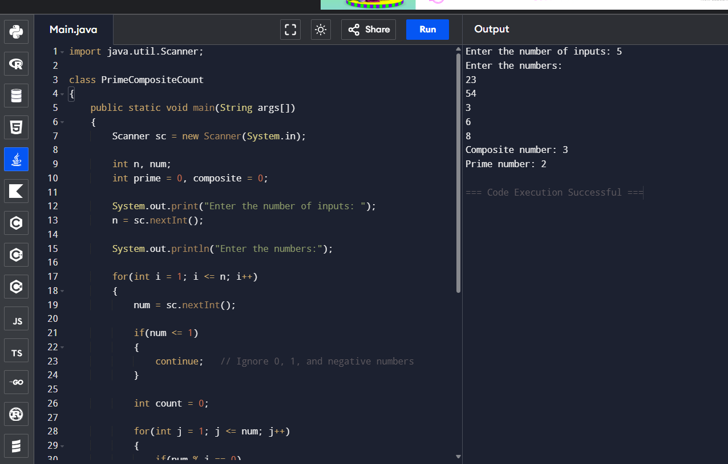

- Find the Mth maximum number and N^{th} minimum number in an array and then find the sum of it and difference of it.
Sample Input:
Array of elements = {14, 16, 87, 36, 25, 89, 34}
M = 1
N = 3
Sample Output:
1stMaximum Number = 89
3rdMinimum Number = 25
Sum = 114
Difference = 64
Test cases:
- {16, 16, 16 16, 16}, M = 0, N = 1
- {0, 0, 0, 0}, M = 1, N = 2
- {-12, -78, -35, -42, -85}, M = 3 , N = 3
- {15, 19, 34, 56, 12}, M = 6 , N = 3
- {85, 45, 65, 75, 95}, M = 5 , N = 7
OUTPUT:

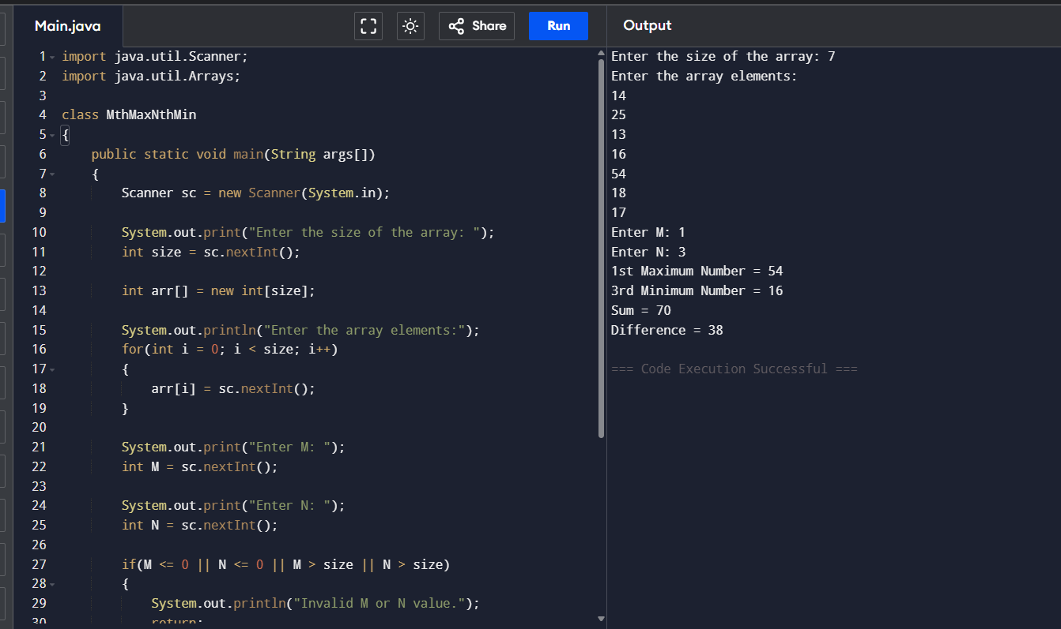

- Write a program to print the total amount available in the ATM machine with the conditions applied.
Total denominations are 2000, 500, 200, 100, get the denomination priority from the user and the total number of notes from the user to display the total available balance to the user
Sample Input:
Enter the 1st Denomination: 500
Enter the 1st Denomination number of notes: 4
Enter the 2nd Denomination: 100
Enter the 2nd Denomination number of notes: 20
Enter the 3rd Denomination: 200
Enter the 3rd Denomination number of notes: 32
Enter the 4th Denomination: 2000
Enter the 4th Denomination number of notes: 1
Sample Output:
Total Available Balance in ATM: 12400

Test Cases:
3 Hidden Test cases (Think Accordingly based on Denominations)
OUTPUT:
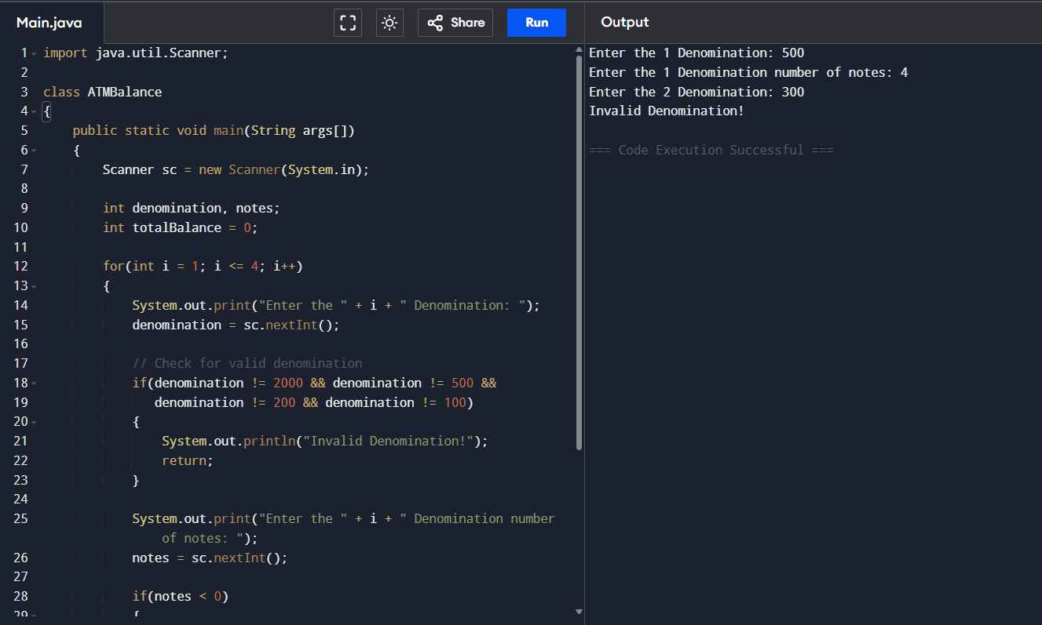

- Write a program using choice to check
Case 1: Given string is palindrome or not
Case 2: Given number is palindrome or not
Sample Input:
Case = 1
String = MADAM
Sample Output:
Palindrome
Test cases:
- MONEY
- 5678765
- MALAY12321ALAM
- MALAYALAM
- 1234.4321
OUTPUT:
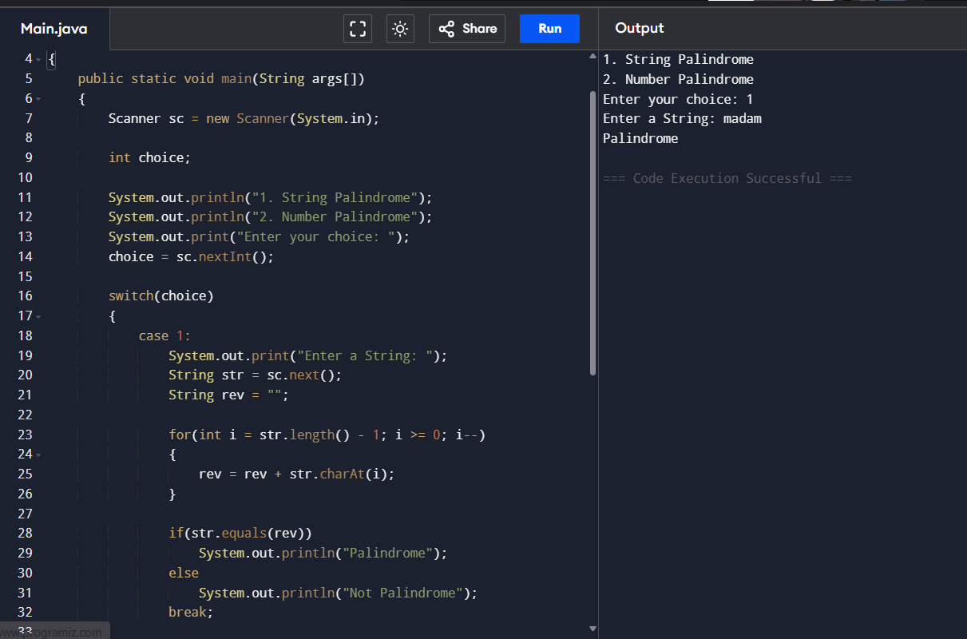
- Write a program to convert Decimal number equivalent to Binary number and octal numbers?
Sample Input:
Decimal Number: 15
Sample Output:
Binary Number = 1111
Octal = 17
Test cases:
- 111
- 15.2
- 0
- B12
- 1A.2
OUTPUT:
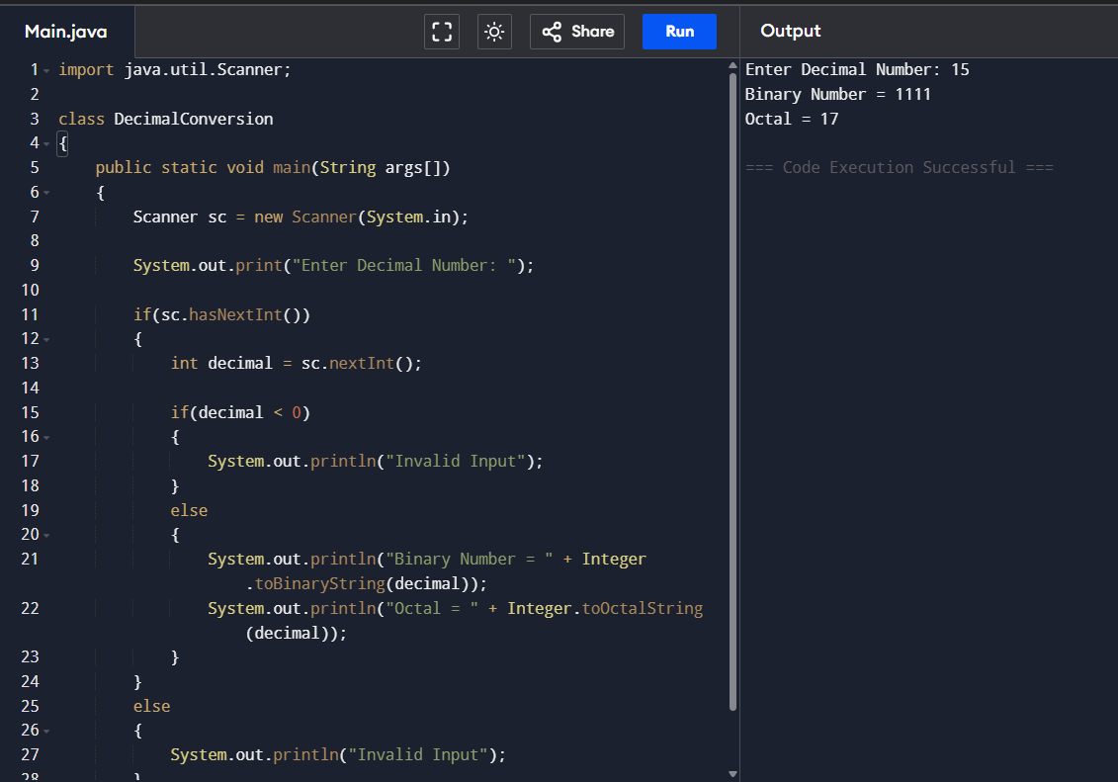
- In an organization they decide to give bonus to all the employees on New Year. A 5% bonus on salary is given to the grade A workers and 10% bonus on salary to the grade B workers. Write a program to enter the salary and grade of the employee. If the salary of the employee is less than $10,000 then the employee gets an extra 2% bonus on salary Calculate the bonus that has to be given to the employee and print the salary that the employee will get.
Sample Input & Output:
Enter the grade of the employee: B
Enter the employee salary: 50000
Salary=50000
Bonus=5000.0
Total to be paid:55000.0
Test cases:
- Enter the grade of the employee: A
Enter the employee salary: 8000
- Enter the grade of the employee: C
Enter the employee salary: 60000
- Enter the grade of the employee: B
Enter the employee salary: 0
- Enter the grade of the employee: 38000
Enter the employee salary: A
- Enter the grade of the employee: B
Enter the employee salary: -8000
OUTPUT:
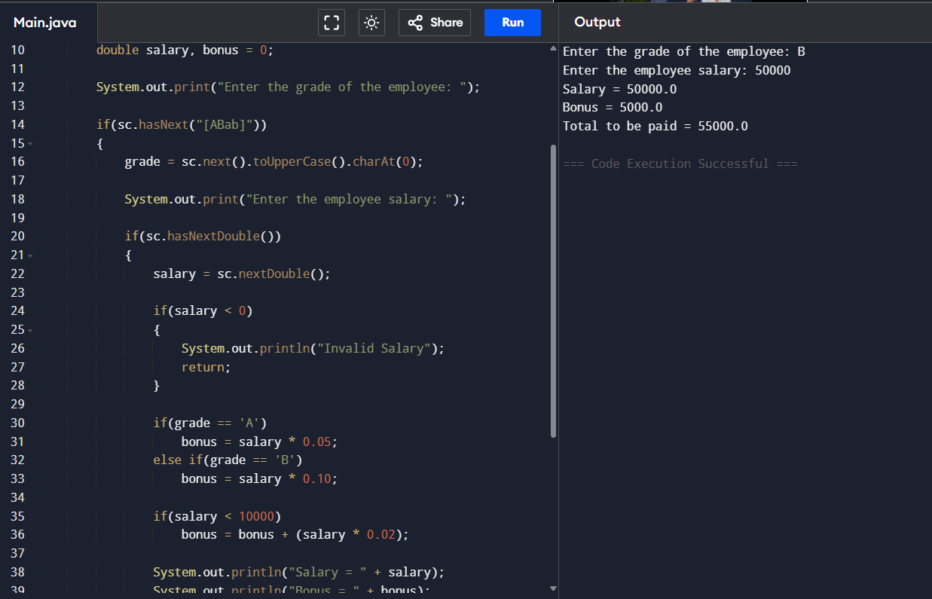

- Write a program to print the first n perfect numbers. (Hint Perfect number means a positive integer that is equal to the sum of its proper divisors)
Sample Input:
N = 3
Sample Output:
First 3 perfect numbers are: 6 , 28 , 496
Test Cases:
- N = 0
- N = 5
- N = -2
- N = -5
- N = 0.2
OUTPUT:
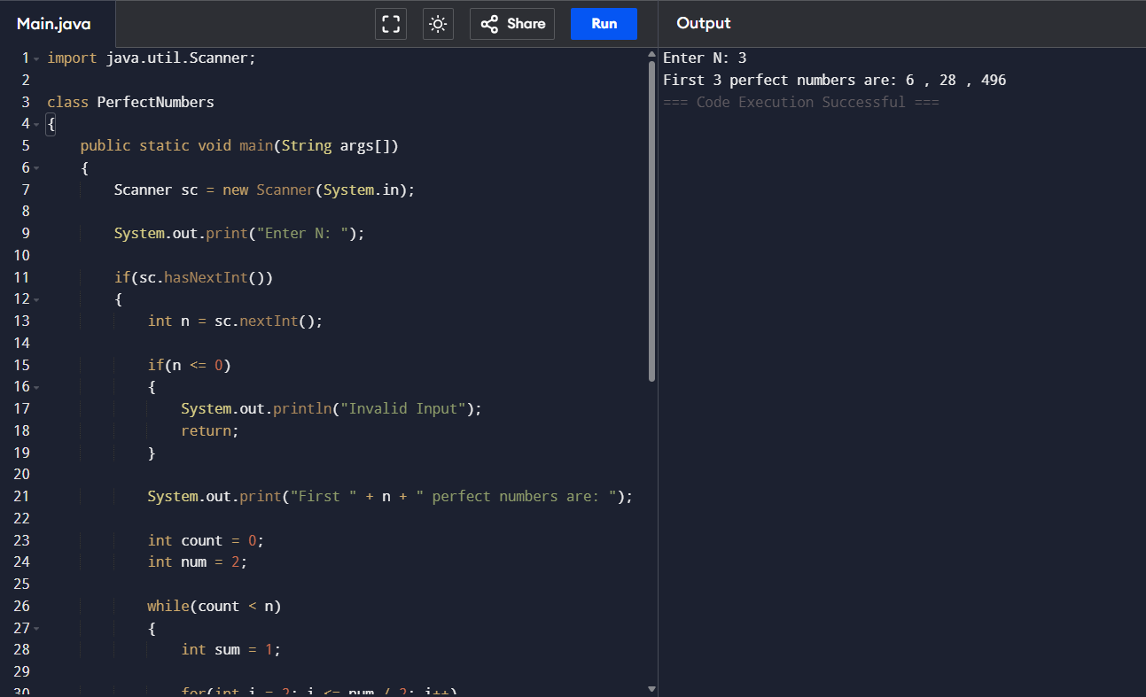
- Write a program to enter the marks of a student in four subjects. Then calculate the total and aggregate, display the grade obtained by the student. If the student scores an aggregate greater than 75%, then the grade is Distinction. If aggregate is 60>= and <75, then the grade is First Division. If aggregate is 50 >= and <60, then the grade is Second Division. If aggregate is 40>= and <50, then the grade is Third Division. Else the grade is Fail.

Sample Input & Output:
Enter the marks in python: 90
Enter the marks in c programming: 91
Enter the marks in Mathematics: 92
Enter the marks in Physics: 93
Total= 366
Aggregate = 91.5
DISTINCTION
Test cases:
- 18, 76,93,65
- 73,78,79,75
- 98,106,120,95
- 96,73, -85,95
- 78,59.8,76,79
OUTPUT:
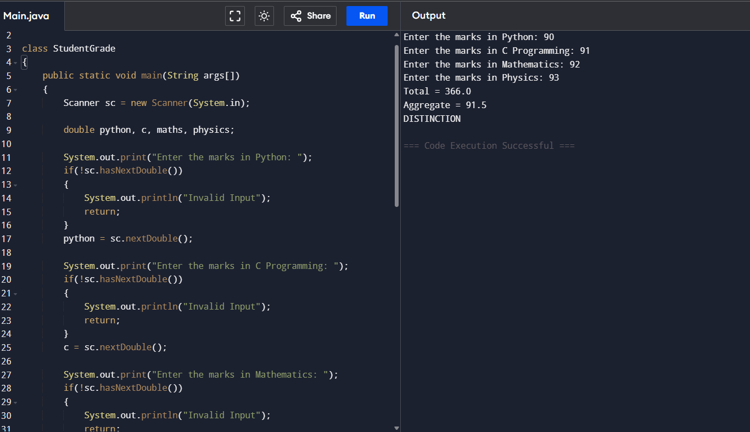

- Write a program to read the numbers until -1 is encountered. Find the average of positive numbers and negative numbers entered by user.
Sample Input:
Enter -1 to exit…
Enter the number: 7
Enter the number: -2
Enter the number: 9
Enter the number: -8
Enter the number: -6
Enter the number: -4
Enter the number: 10
Enter the number: -1
Sample Output:
The average of negative numbers is: -5.0
The average of positive numbers is : 8.66666667
Test cases:
- -1,43, -87, -29, 1, -9
- 73, 7-6,2,10,28,-1
- -5, -9, -46,2,5,0
- 9, 11, -5, 6, 0,-1
- -1,-1,-1,-1,-1
OUTPUT:
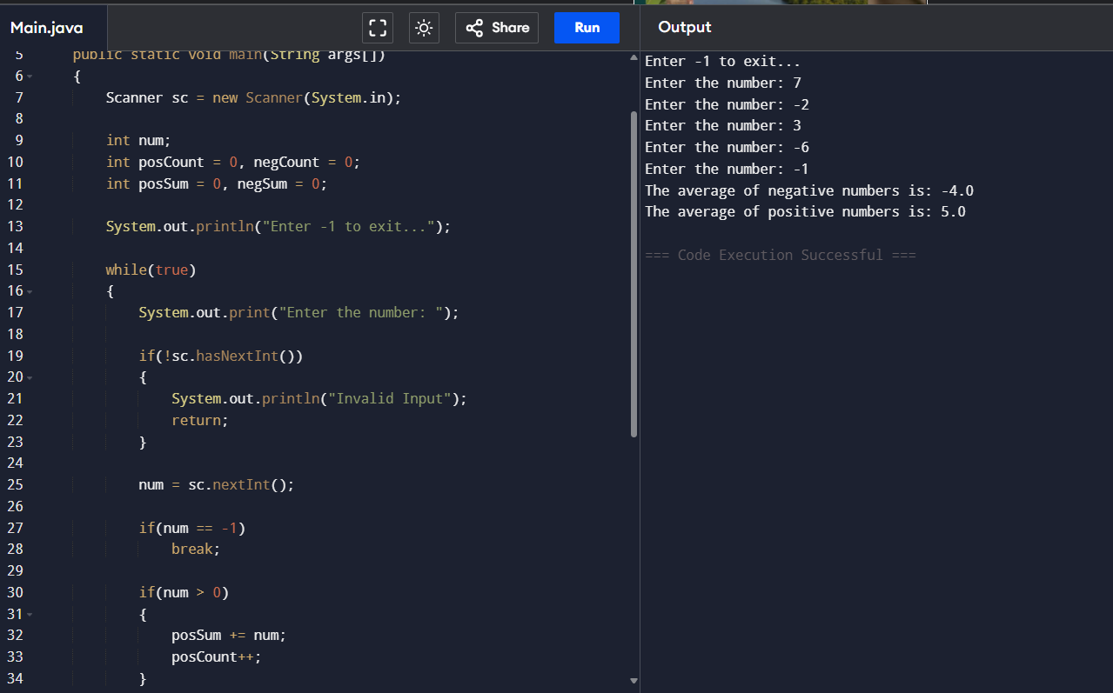
- Write a program to read a character until a * is encountered. Also count the number of uppercase, lowercase, and numbers entered by the users.
Sample Input:
Enter * to exit…
Enter any character: W
Enter any character: d
Enter any character: A
Enter any character: G
Enter any character: g
Enter any character: H
Enter any character: *
Sample Output:
Total count of lower case:2
Total count of upper case:4
Total count of numbers =0
Test cases:
- 1,7,6,9,5
- S, Q, l, K,7, j, M
- M, j, L, &, @, G
- D, K, I, 6, L, *
- *, K, A, e, 1, 8, %, *
OUTPUT:
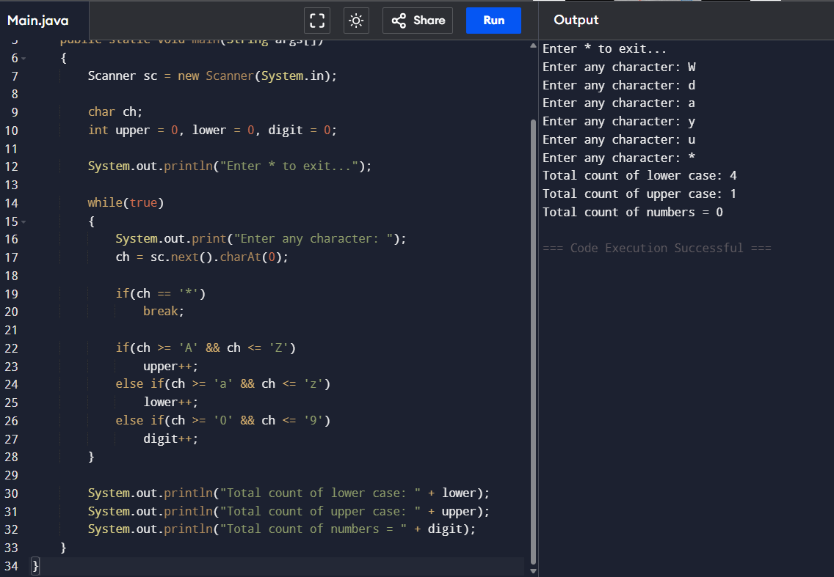
- Write a program to calculate the factorial of number using recursive function.
Sample Input & Output:
Enter the value of n: 6
Sample Input & Output:
The factorial of 6 is: 720
Test cases:
- N = 0
- N = -5
- N = 1
- N = M
- N = %
OUTPUT:
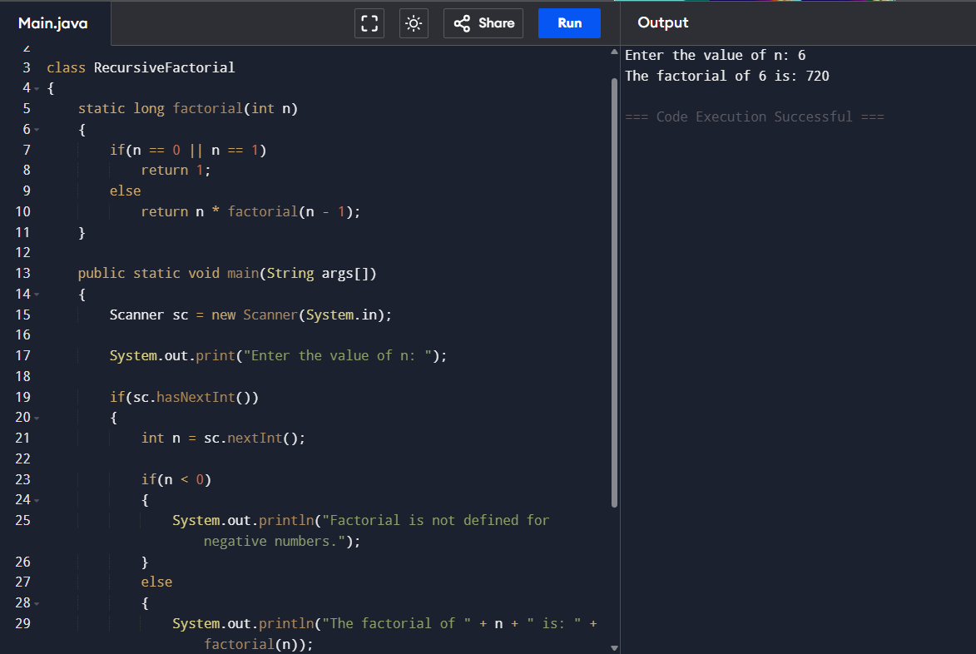
- Write a Program to Find the Nth Largest Number in a array.
Sample Input:
List : {14, 67, 48, 23, 5, 62}
N = 4
Sample Output:
4th Largest number: 23

Test cases:
- N = 0
- N = -5
- N = 1
- N = M
- N = %
OUTPUT:
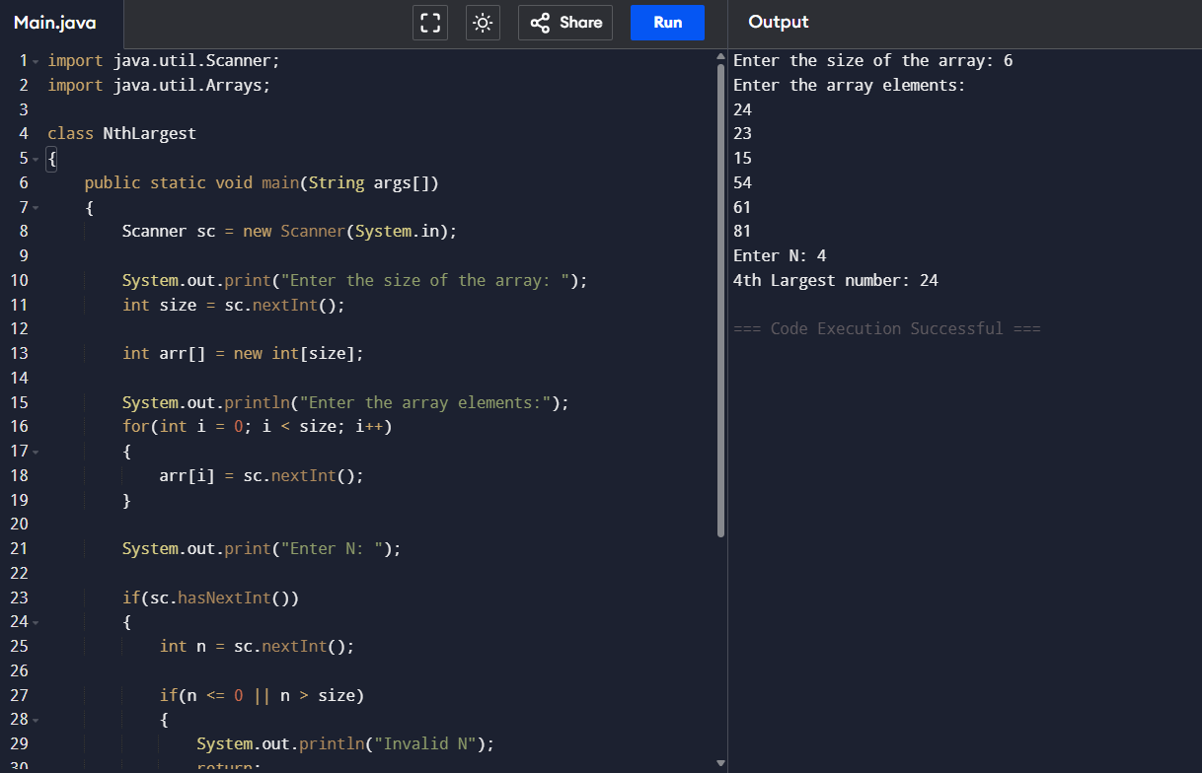
- Write a program to convert the Binary to Decimal, Octal
Sample Input:
Given Number: 1101
Sample Output:
Decimal Number: 13
Octal:15
Test cases:
- 211
- 11011
- 22122
- 111011.011
- 1010.0101

OUTPUT:
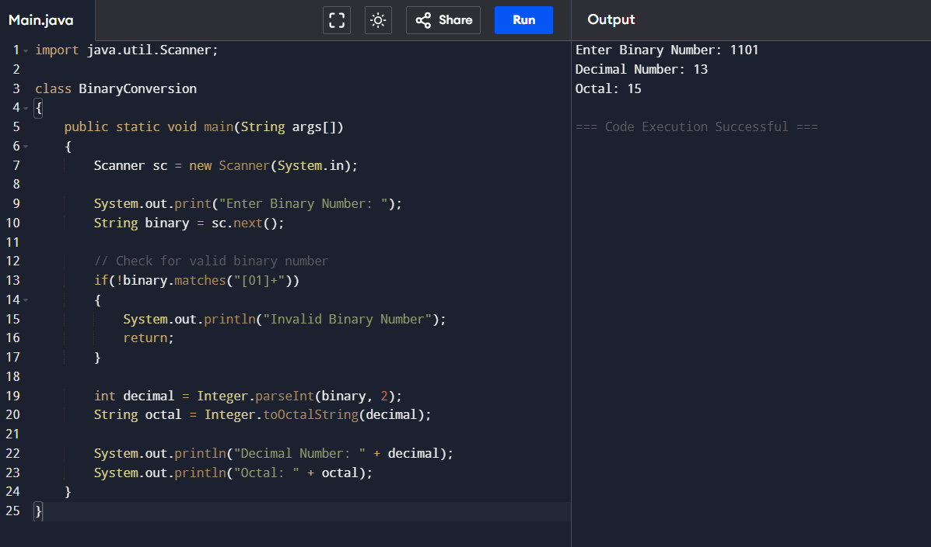
- Write a program to find the number of special characters in the given statement
Sample Input:
Given statement: Modi Birthday @ September 17, #&$% is the wishes code for him.
Sample Output:
Number of special Characters: 5

OUTPUT:
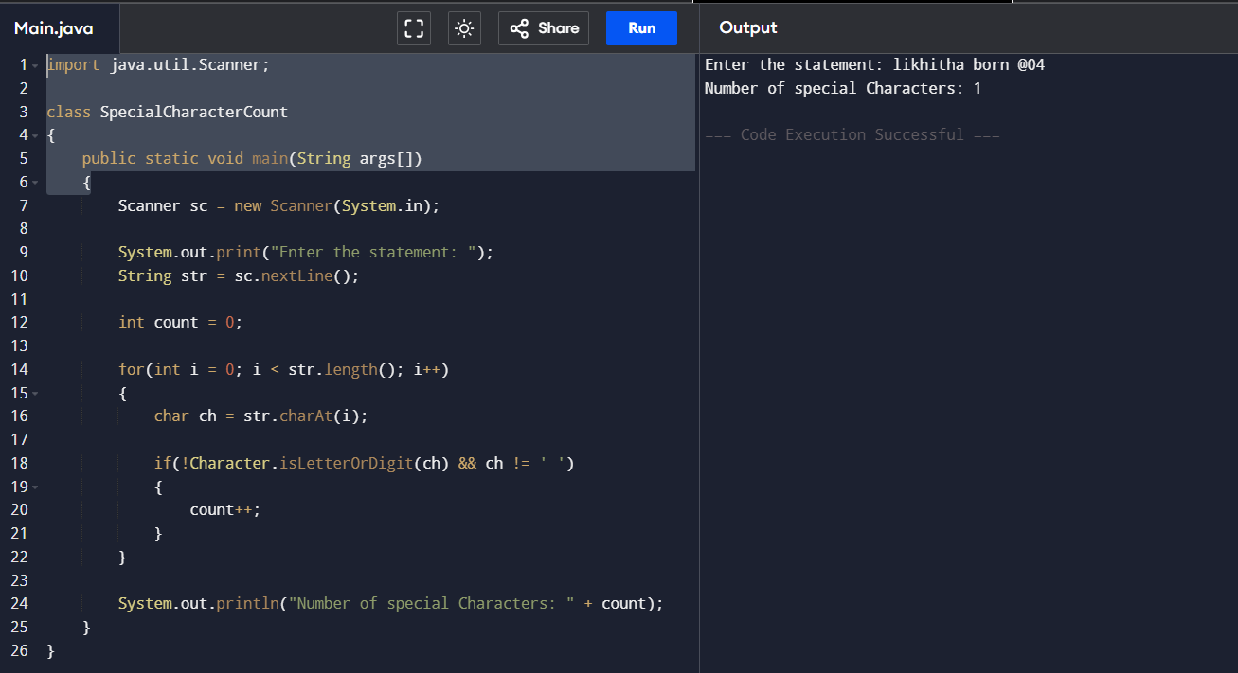

- Write a Program to Remove the Duplicate Items from a array.
Sample Input:
Enter the number of elements in array:7
Enter element1:10
Enter element2:20
Enter element3:20
Enter element4:30
Enter element5:40
Enter element6:40
Enter element7:50
Sample Output:
Non-duplicate items:
[10, 20, 30, 40, 50]
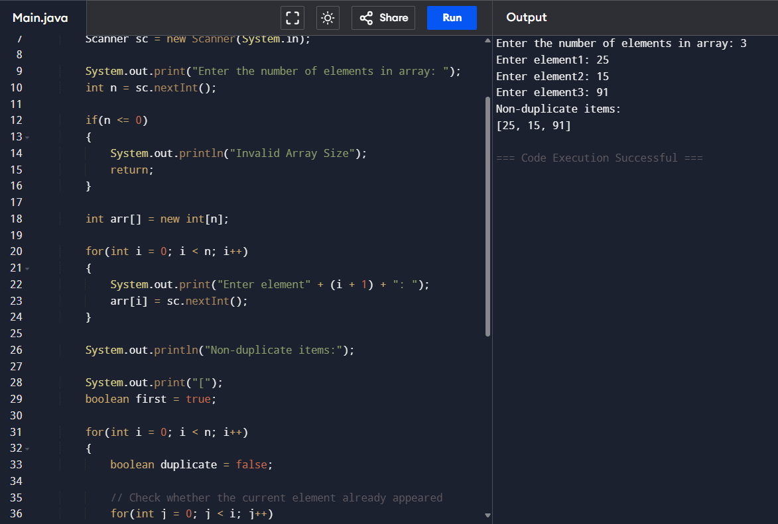
OUTPUT:

